**Question:**

Query the **NAME** field for all American cities in the **CITY** table with populations larger than 120000. The CountryCode for America is USA.

The **CITY** table is described as follows:  
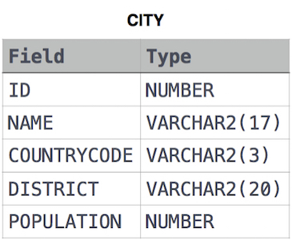

**Solution:**

select name from city where countrycode='usa' and population>120000

**Output:**

